**1] Configure an Ubuntu node using the execution of a command on the master method. Here we done this on AWS.**

## - Make sure at any point in time, a maximum of 5 jobs can be executed on this node.

## - Assign this node to Assignment 1

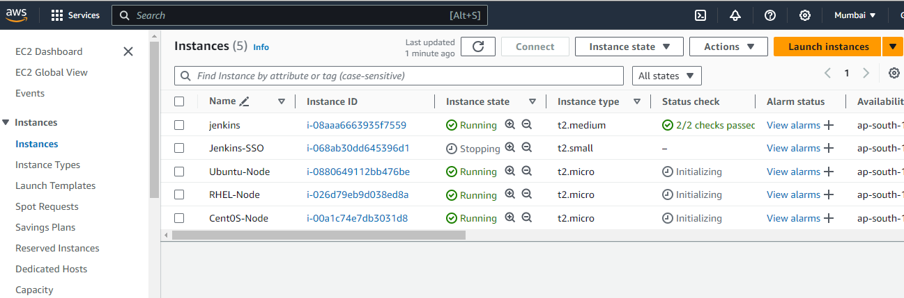

**Configure the instance as need & SSh**

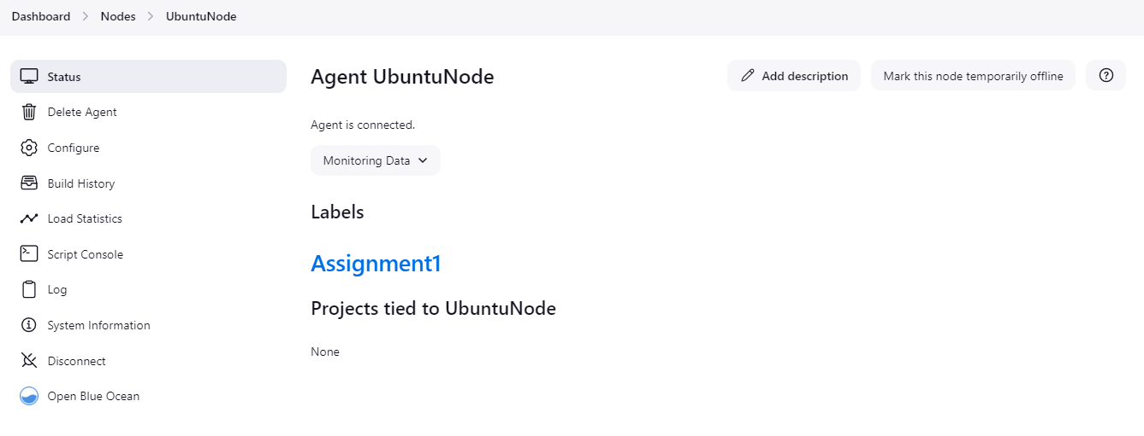

**–––**

**2] Configure a CentOS node using Launch slave agents via SSH method.**

## - Make sure at any point of time a maximum of 2 jobs can be executed on this node.

## - Assign this node to Assignment 2

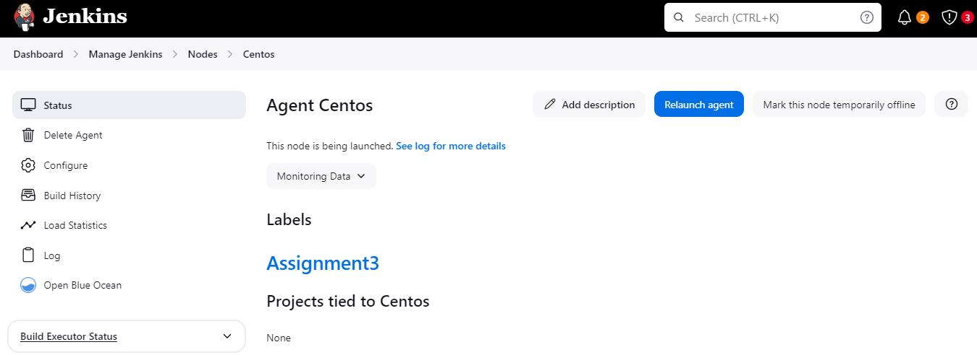

Console output is success

## 3] Configure a RHEL node using Launch slave agents via SSH method.

## - Make sure at any point in time a maximum of 3 jobs can be executed on this node.

## - Assign this node to Assignment 3

